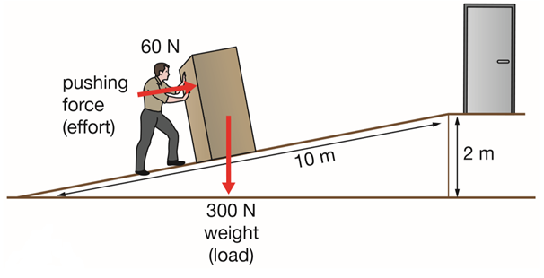**RAMPS**

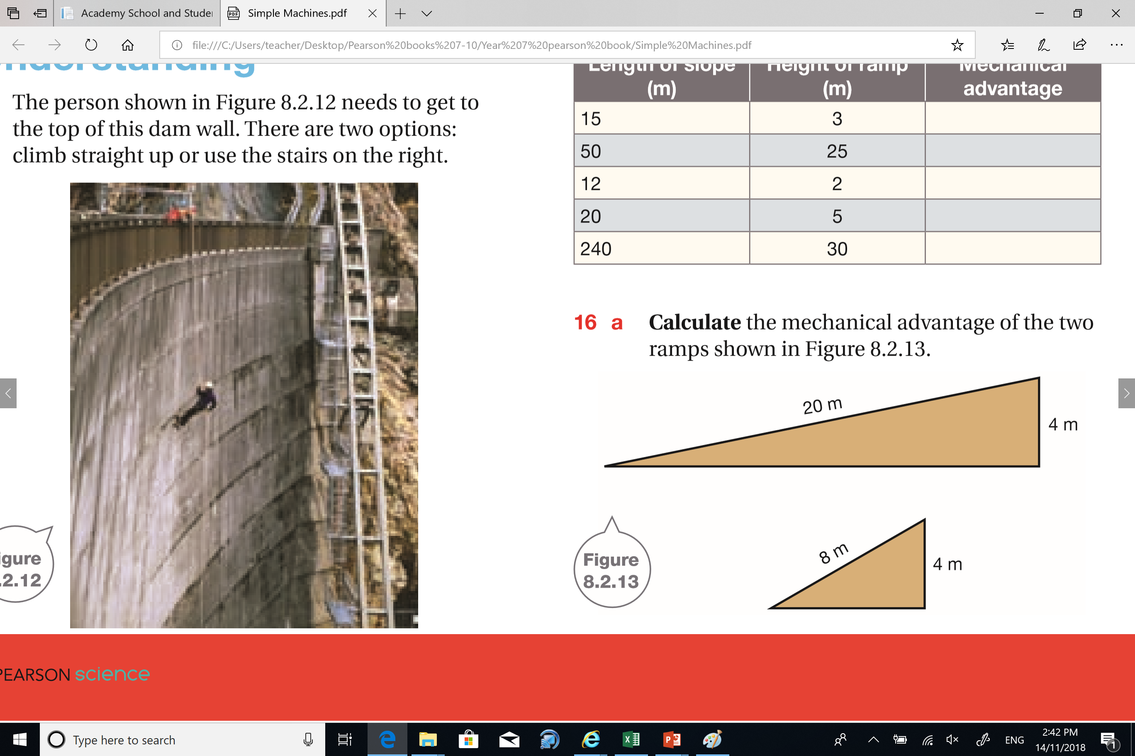Mechanical Advantage = = = =

Mechanical Advantage = $\frac{Ramp Length}{Ramp Height}$ = = =



Mechanical Advantage = $\frac{Ramp Length}{Ramp Height}$ = = =

|  |  |  |
| --- | --- | --- |
| **Length of Slope (m)** | **Height of Ramp (m)** | **Mechanical Advantage** |
| 15 | 3 |  |
| 50 | 25 |  |
| 12 | 2 |  |
| 20 | 5 |  |
| 240 | 30 |  |

**RAMPS**

Mechanical Advantage = $\frac{Ramp Length}{Ramp Height}$ = = =

Mechanical Advantage = $\frac{Ramp Length}{Ramp Height}$ = = =



Mechanical Advantage = $\frac{Ramp Length}{Ramp Height}$ = = =

|  |  |  |
| --- | --- | --- |
| **Length of Slope (m)** | **Height of Ramp (m)** | **Mechanical Advantage** |
| 15 | 3 |  |
| 50 | 25 |  |
| 12 | 2 |  |
| 20 | 5 |  |
| 240 | 30 |  |